Palm Sunday (From Luke 19: 28-40; Mark 11:1-11; Matthew 21:1-11)
Jesus was walking towards Jerusalem with his disciples (his close friends who travelled around with him).
Go to the village ahead of you, and you will find a donkey there, with her colt, a young donkey, by her. Untie them and bring them to me. If anyone says anything to you, say that the Lord needs them.
He said to two of them:

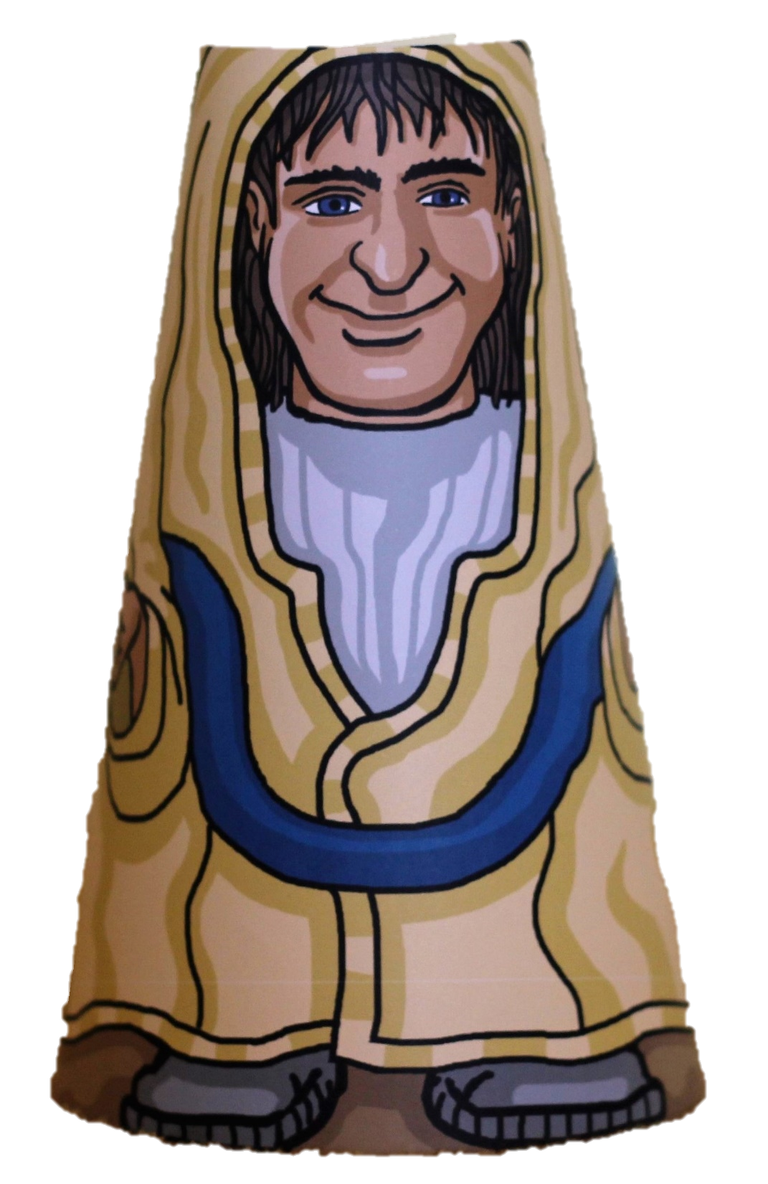

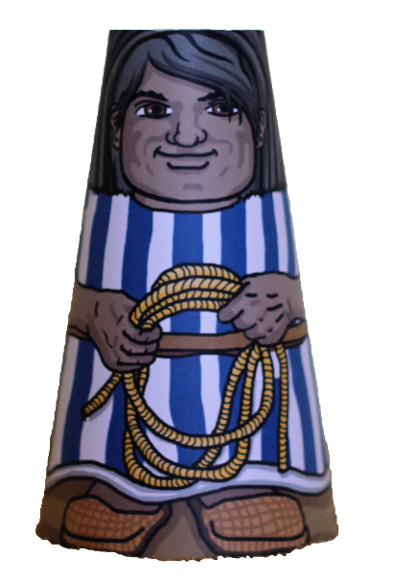
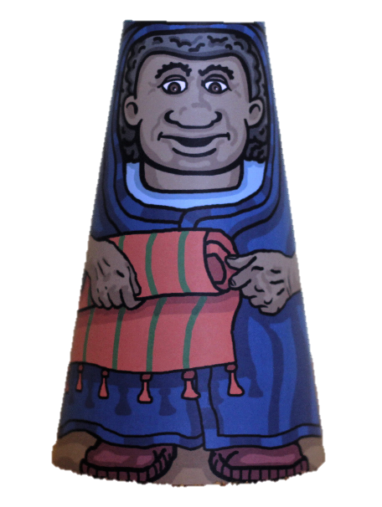

So they did as Jesus had asked. They went to the village and they found the donkey and the colt just as Jesus had said and, when some people nearby asked what they were doing, they said:

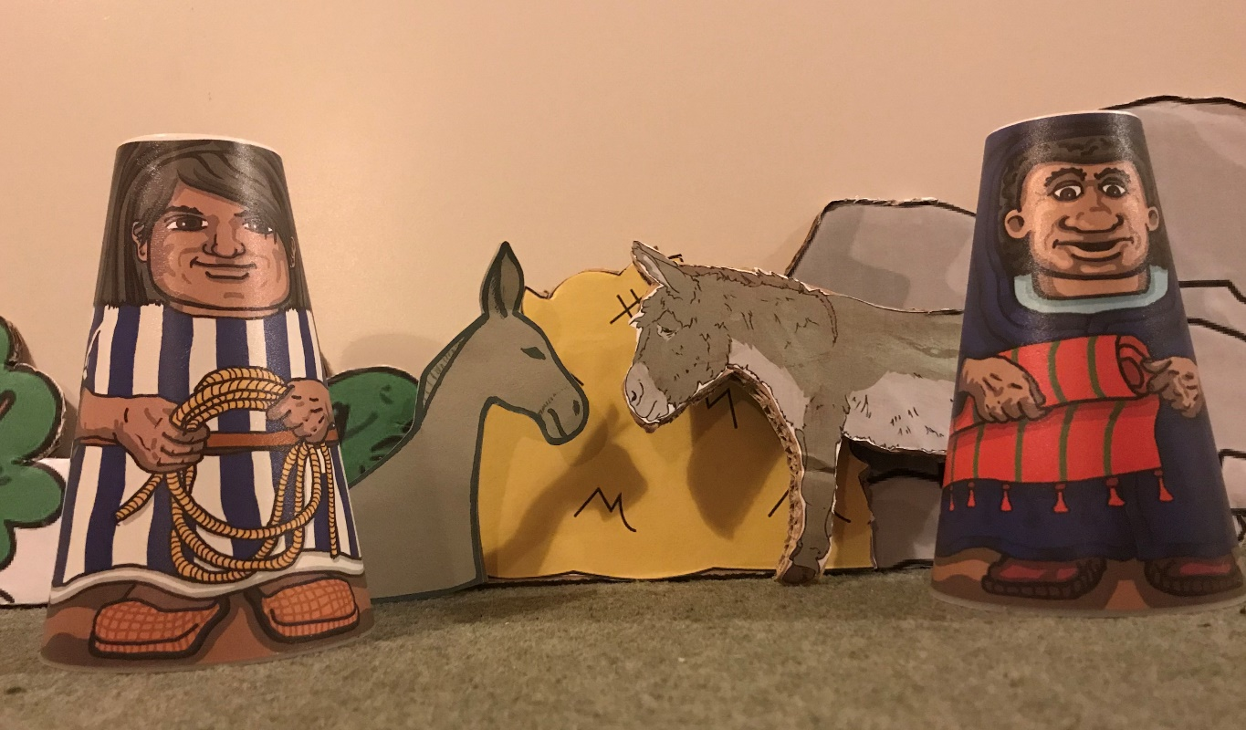
The Lord needs them!
They brought the donkey and the colt and placed their cloaks on them for Jesus to sit on. A very large crowd spread their cloaks on the road, while others cut branches from the trees and spread them on the road.

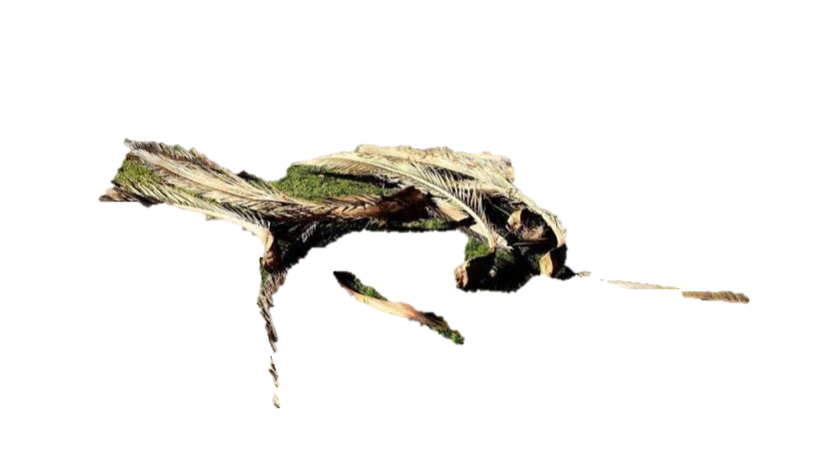
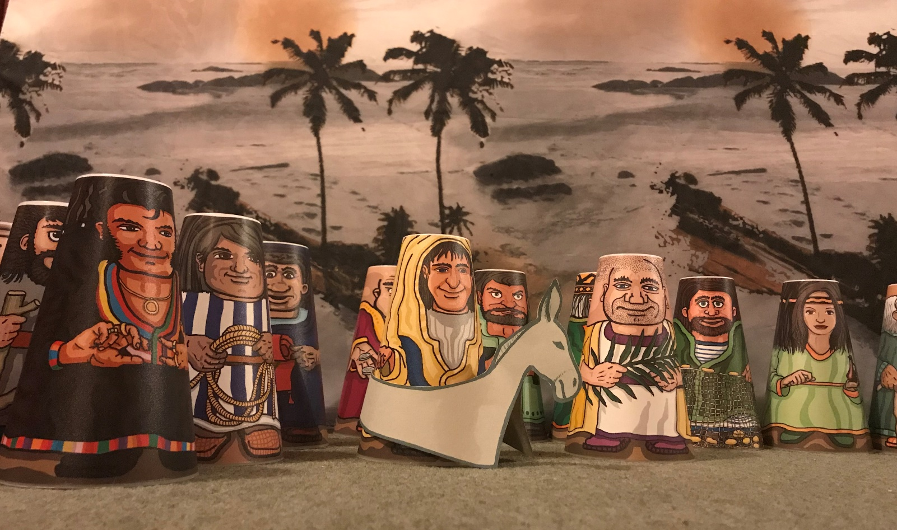

The crowds that went ahead of Jesus and those that followed shouted:
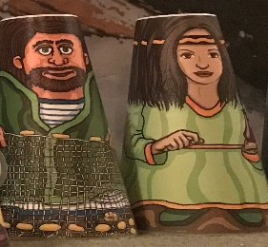
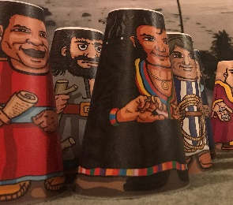
“Hosanna to the Son of David!”
“Blessed is he who comes in the name of the Lord!”
“Hosanna in the highest heaven!”

This is like shouting, ‘Save us, please save us!’ They wanted Jesus to rescue them – perhaps to rescue them from the Romans or perhaps they knew from their history that God had promised a rescuer. Perhaps they didn’t quite know which type of rescue they meant but they knew that Jesus was special, even though they didn’t know exactly who he was.
When Jesus entered Jerusalem, the city was buzzing with excitement and people were asking, “Who is this?”
The crowds following Jesus answered, “This is Jesus, the prophet from Nazareth in Galilee.”
In the days that followed, these people would be amazed by what they saw and heard.

